Postprocessor User's Guide for Makino V33

This is a 3-Axis Milling Machine.

In order to use this postprocessor correctly, you should follow the instruction below.

1. UDE installation
- Copy the UDE-file (unique to this kit) into the UDE directory: UGII_CAM_USER_DEF_EVENT_DIR (typically mach\resource\user_def_event)
- If the file already exists it will be overwritten!
2. in the program order view
- Add the Coolant ON UDE to the operation
  - Highlight the operation which you want to specify the type of coolant, using MB3, select OBJECT→ Start Events. The User Defined Events dialog is displayed.
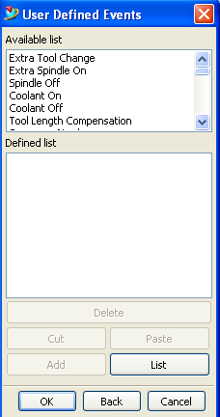
  - Select ‘Coolant On’ from the Available list items, then choose the Add button.
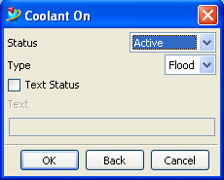
  - Set the Status as Active.
  - Select the type
  - OK
- Add the super GI ON UDE to the operation
  - Highlight the operation which you want to turn super GI on, using MB3, select OBJECT→ Start Events. The User Defined Events dialog is displayed.
  - Select ‘super GI On’ from the Available list items, then choose the Add button.
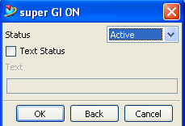
  - Set the Status as Active.
  - OK
- Then you can use this postprocessor to output the G code directly.

